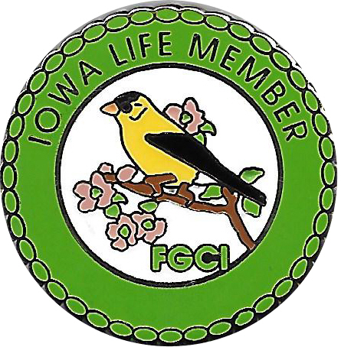

FEDERATED GARDEN CLUBS OF IOWA, INC.

STATE LIFE MEMBERSHIP APPLICATION

FGCI Life Membership Donation is $25.00

Please Print

Name: ______________________________________________________________________________
Address: _____________________________________________________________________________
City: _______________________________________ State: ___________ Zip:____________________
Phone: ______________________________________ Email: __________________________________
Name of Your Garden Club: _____________________________________________________________
City of Your Garden Club: ______________________________________________________________

Please send application and $25 check (made out to: Federated Garden Clubs of Iowa)

Send To: Sandra R. Wales (Life Membership Chair)
2465 Cardinal Court
Muscatine, Iowa 52761
Further Information or Questions:
Phone (563) 264-0156 Cell (563)299-1873
Email: wales@machlink.com

(The new State Life Member Pin is included with your new Life Membership)

